
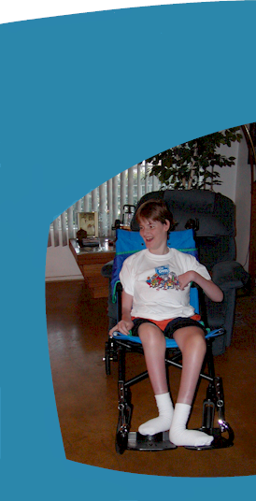

A 501(c)3 non-profit organization
www.SHAREnetwork.org
The SHARE Network was originally founded in 1999 and went online on February 7th, 2000. Our main goal and mission is to provide an alternative means for obtaining services, equipment and information for those with special needs.
A network of families and friends sharing services and equipment for those who have special needs.
SHARE Network
2359 E Kenwood St
Mesa, AZ USA
85213
(602) 277-7504
www.SHAREnetwork.org
information@sharenetwork.org

SHARE Network
Special Help And Respite Exchange Network
United Way Group #2311
(National Location, Phoenix AZ 85013)
- A FREE service for all
- 100% of all donations go right back out to those in our network
- List your need
- List what you have available for others for trade or sale
- Connect to others in similar situations


Please help others by donating:
- Your time
- Gently used medical equipment
- Your services
- Household goods
- Diapers
- Money
- Vehicles
- Pop Tabs
Support the SHARE Network
donation@sharenetwork.org

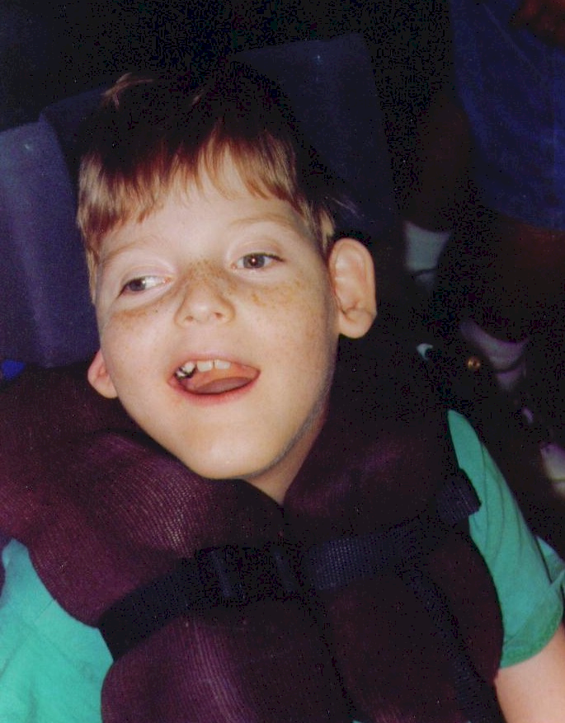



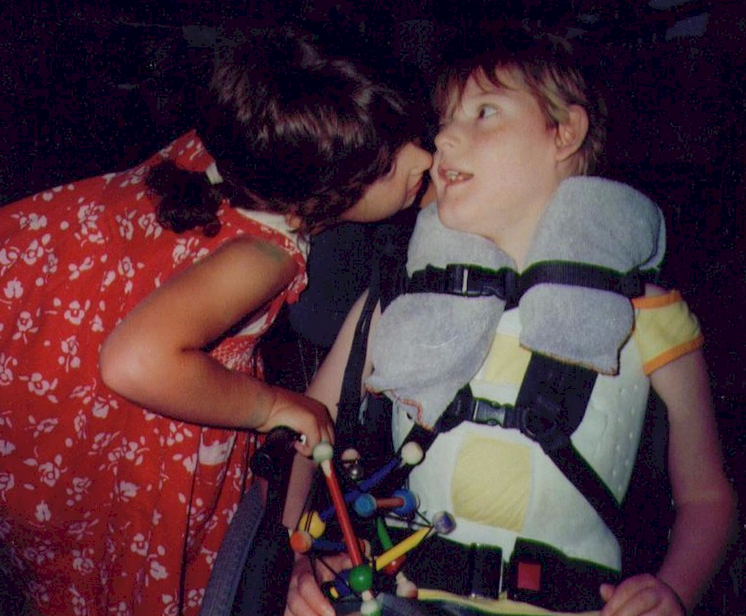
Information and Resources
Equipment and Services
Grant Programs
Parent Exchange
Education
Donation and Volunteer Opportunities
“We can’t always choose the circumstances we are given, but we certainly can choose to make the best of them for ourselves and for others.”
Chava Cannon
Founder – Executive Director
One person can make a difference
Non-profit agency web design assistance program available.

This program assists other non-profit organizations or those organizations in the process of becoming non-profit with basic web site development assistance which can include but is not limited to development, graphics design, building the site, search engine submissions, web optimization and consulting. For more information, contact the SHARE Network at: wd_grant@sharenetwork.org

A 501(c)3 non-profit organization

 RESPITE
 TRANSPORTATION
.

 SERVICES

 EQUIPMENT

 VANS - CARS

 OTHER
Welcome To Holland
I am often asked to describe the experience of raising a child with a disability - to try to help people who have not shared that unique experience to understand it, to imagine how it would feel. It's like this...
When you're going to have a baby, it's like planning a fabulous vacation trip - to Italy. You buy a bunch of guide books and make your wonderful plans. The Coliseum. The Michelangelo David. The gondolas in Venice. You may learn some handy phrases in Italian. It's all very exciting.
After months of eager anticipation, the day finally arrives. You pack your bags and off you go.
Several hours later, the plane lands. The stewardess comes in and says, "Welcome to Holland".
"Holland?!?", you say. "What do you mean, Holland? I signed up for Italy! I'm supposed to be in Italy. All of my life I've dreamed of going to Italy".
But there's been a change in the flight plan. They've landed in Holland and there you must stay.
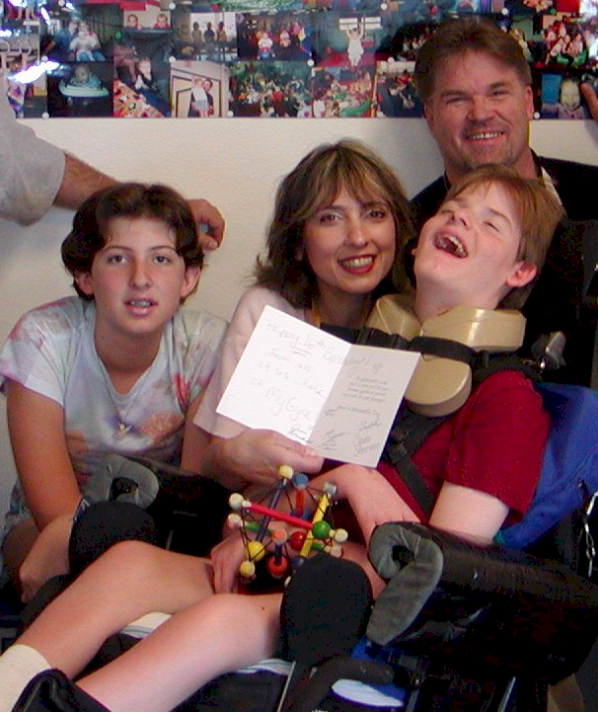

The important thing is that they haven't taken you to a horrible, disgusting, filthy place, full of pestilence, famine, and disease. It's just a different place.
So you must go out and buy new guidebooks. And you will meet a whole new group of people you would have never met.
It's just a different place. It's slower-paced than Italy, less flashy than Italy. But after you've been there for a while and you catch your breath, you look around, and you begin to notice that Holland has windmills. Holland has tulips. Holland even has Rembrandts.
But everyone you know is busy coming and going from Italy, and they're all bragging about what a wonderful time they had there.
And for the rest of your life, you will say, "Yes, that's where I was supposed to go. That's what I had planned".
And the pain of that will never, ever, ever go away, because the loss of that dream is a very significant loss.
But if you spend your life mourning the fact that you
didn't get to go to Italy, you may never be free to enjoy the very special, the very lovely things about Holland.
(author unknown)

